Multiplying by repeated addition  Swimmers | Name:
Multiplying by repeated addition  Swimmers | Date:
Example:
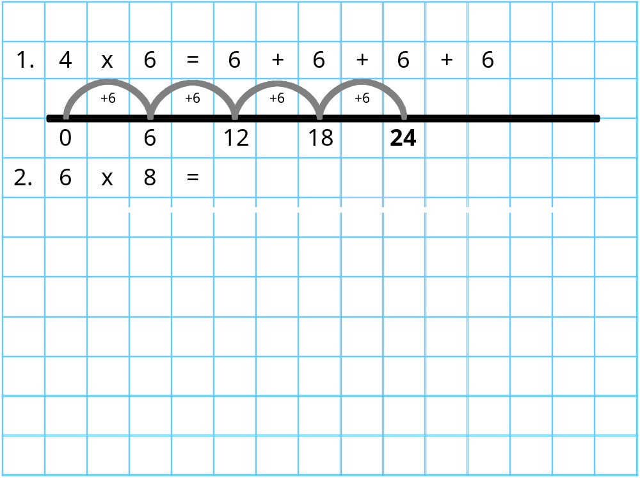

1. 3 x 8 = 8 + 8 + 8
2. 4 x 6 =
3. 5 x 6 =
4. 3 x 9 =
5. 6 x 7 =
6. 4 x 5 =
7. 7 x 5 =
8. 8 x 4 =
9. 5 x 9 =
10. 6 x 8 =
Extra
11.
5 people buy 8 t-shirts each. How many do they buy altogether?
12. 
4 people buy 9 mugs each. How many do they buy altogether?
13. 
7 people buy 12 pens each. How many do they buy altogether?

Multiplying by repeated addition  Basketball and Rugby | Name:
Multiplying by repeated addition  Basketball and Rugby | Date:
Example:

1. 6 x 8 = 8 + 8 + 8 + 8 + 8 + 8
2. 4 x 7 =
3. 5 x 8 =
4. 6 x 9 =
5. 11 x 7 =
6. 4 x 9 =
7. 7 x 6 =
8. 8 x 4 =
9. 9 x 9 =
10. 12 x 8 =
Extra
11.
6 people buy 12 t-shirts each. How many do they buy altogether?
12.
7 people buy 14 mugs each. How many do they buy altogether?
13.
9 people buy 12 pens each. How many do they buy altogether?
Multiplying by repeated addition  Tennis and Footballers | Name:
Multiplying by repeated addition  Tennis and Footballers | Date:
Example:

1. 7 x 8 = 8 + 8 + 8 + 8 + 8 + 8 +8 = 7 + 7 + 7 +7 + 7 + 7 +7 + 7
2. 4 x 5 =
3. 7 x 5 =
4. 8 x 4 =
5. 8 x 9 =
6. 6 x 12 =
7. 14 x 6 =
8. 16 x 5 =
9. 13 x 9 =
10. 12 x 7 =
Extra
11.
9 people buy 7 t-shirts each. How many do they buy altogether?
12.
14 people buy 3 mugs each. How many do they buy altogether?
13.
8 people buy 12 pens each. How many do they buy altogether?

